TASK 4:

* Create a Virtual Machine
* Create a managed disk on azure portal
* Attach the managed disk to the Virtual Machine.

Steps to attach Managed Disk to VM:

Step 1: First, Create Virtual Machine inside Azure portal

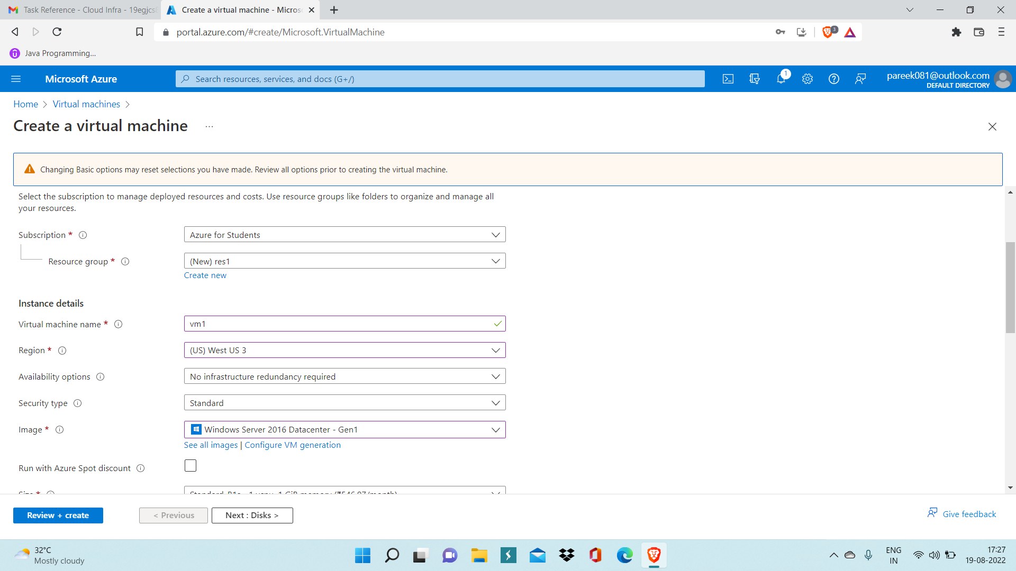

Step 2: Now After virtual machine is deployed, go to overview page of virtual machine

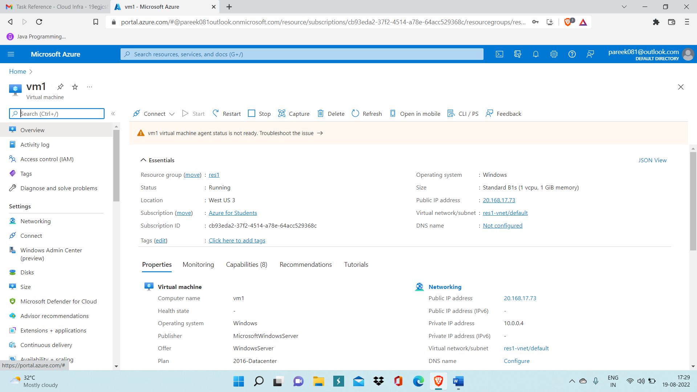

Step 3: Now, go inside Disk settings, and click on ‘Create and attach new disk’.

And enter disk name and specify size of disk, then, click on save.

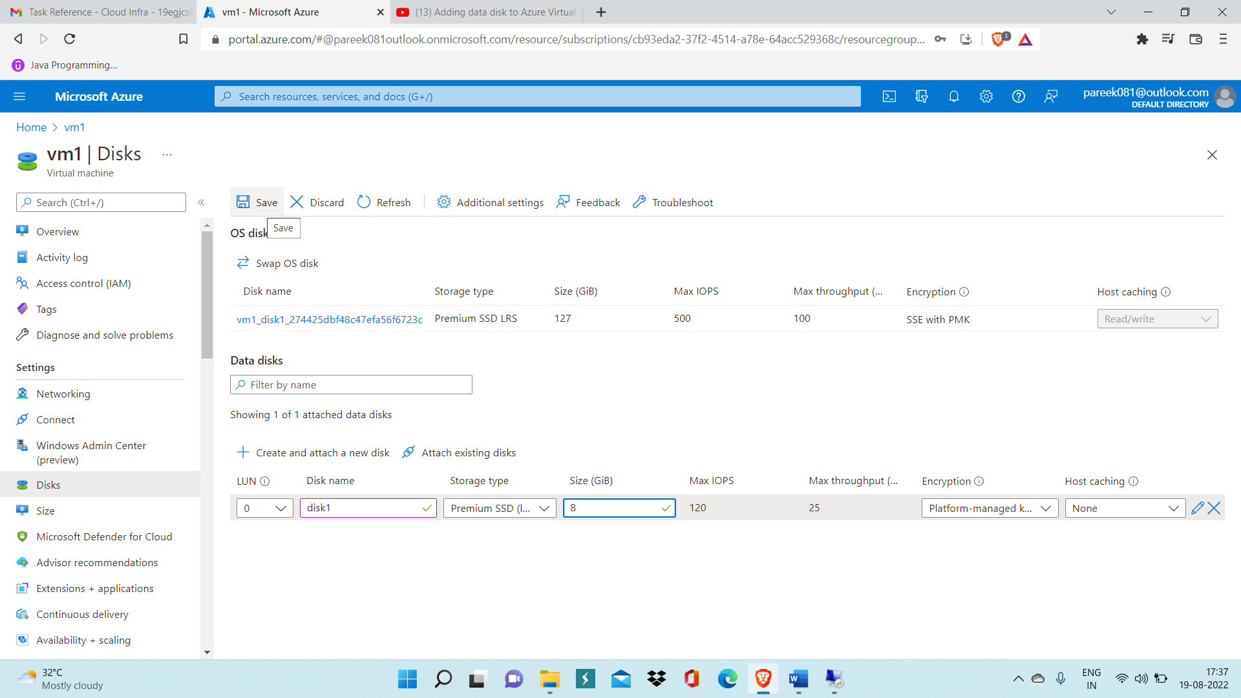

Step 4: Now enter authentication details of VM and open it.

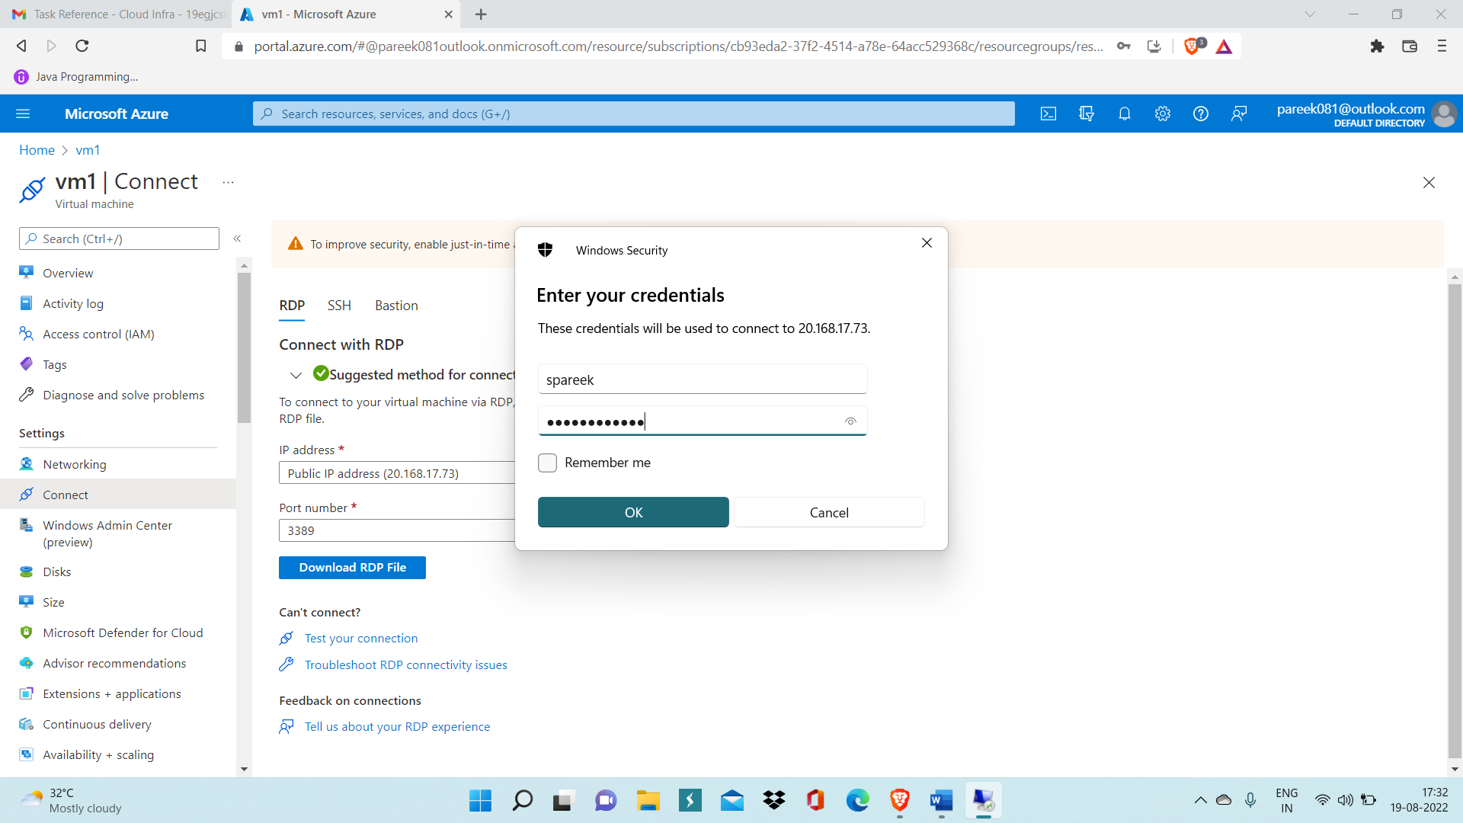

Step 5: You can check that Disk which you gave created is currently not ready for use. To make is usable follow below steps.

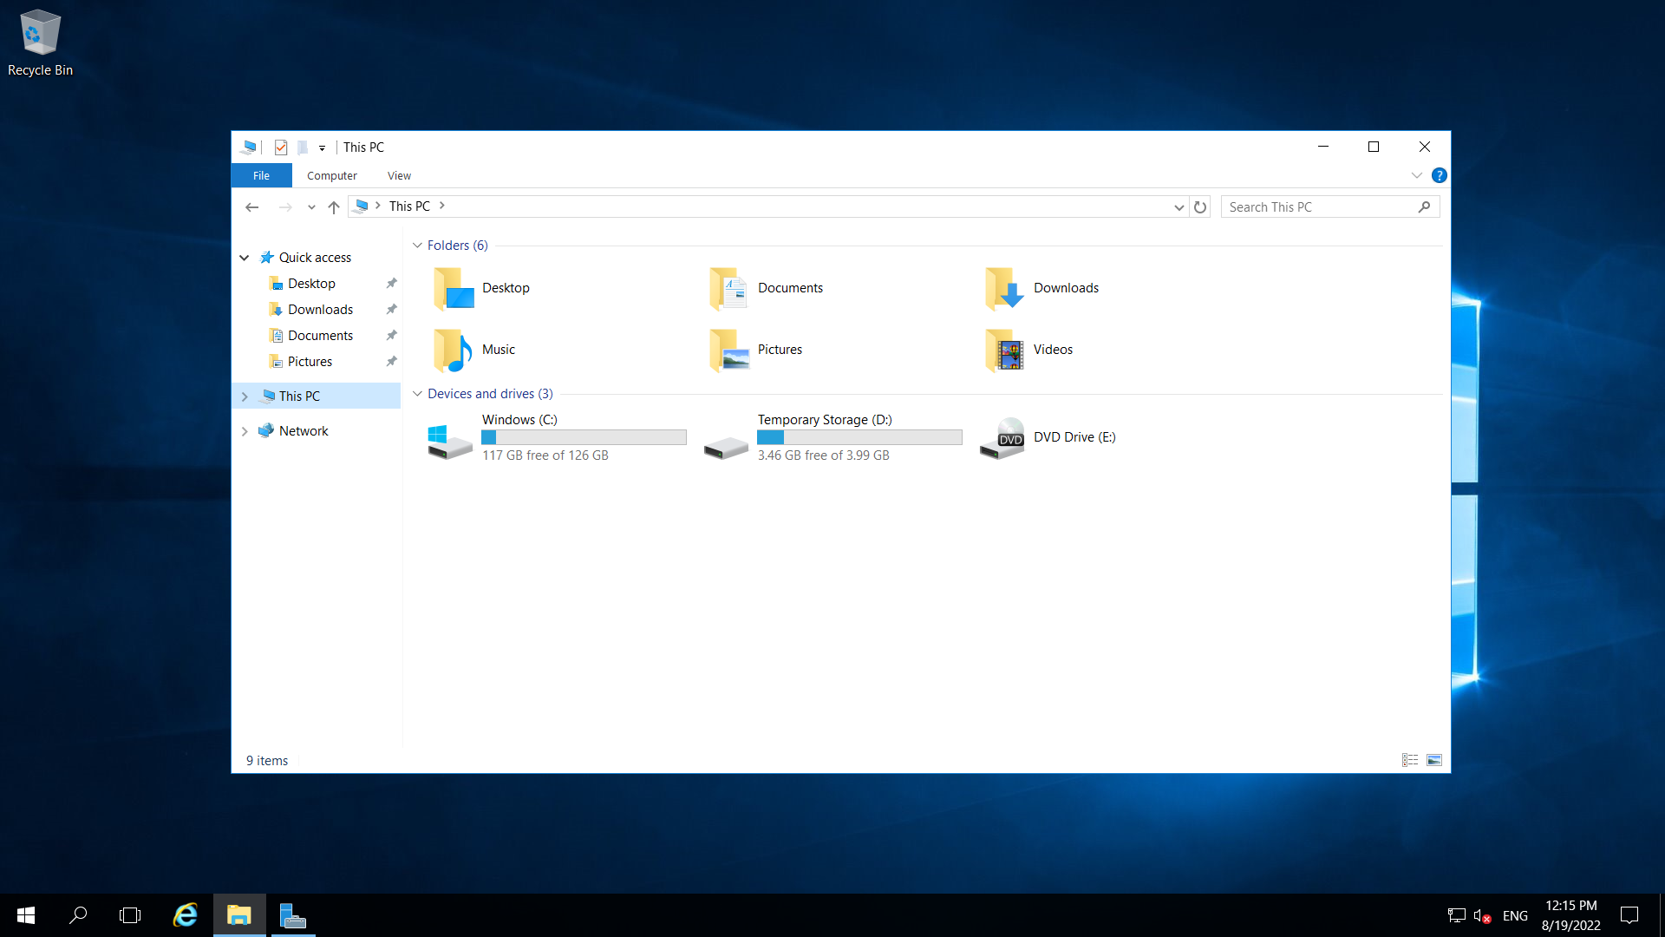

Step 5: Now, Go Inside Server Manager and open File and Disk Storage.

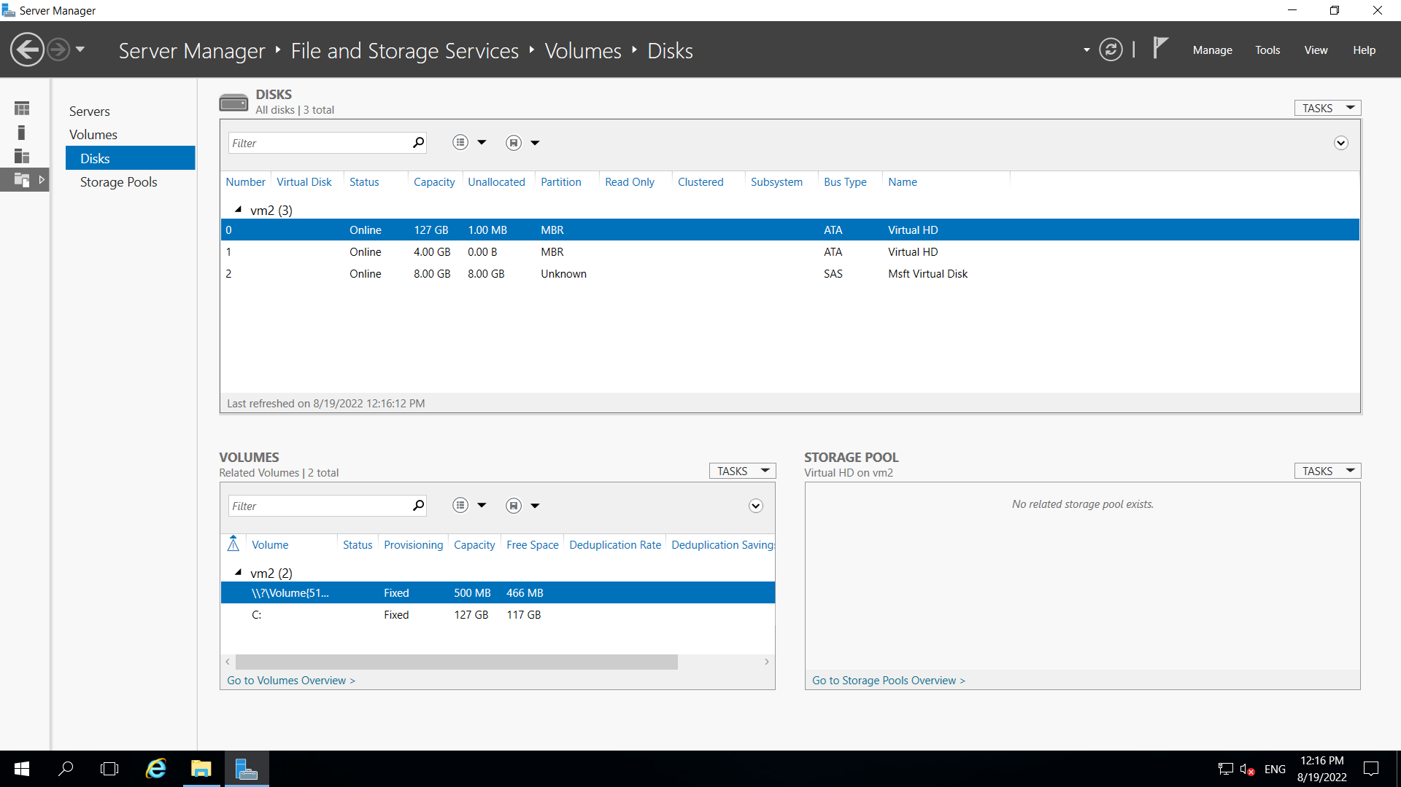

Step 6: Now, right click on the disk you created and click on new volume and then new volume wizard will get open.

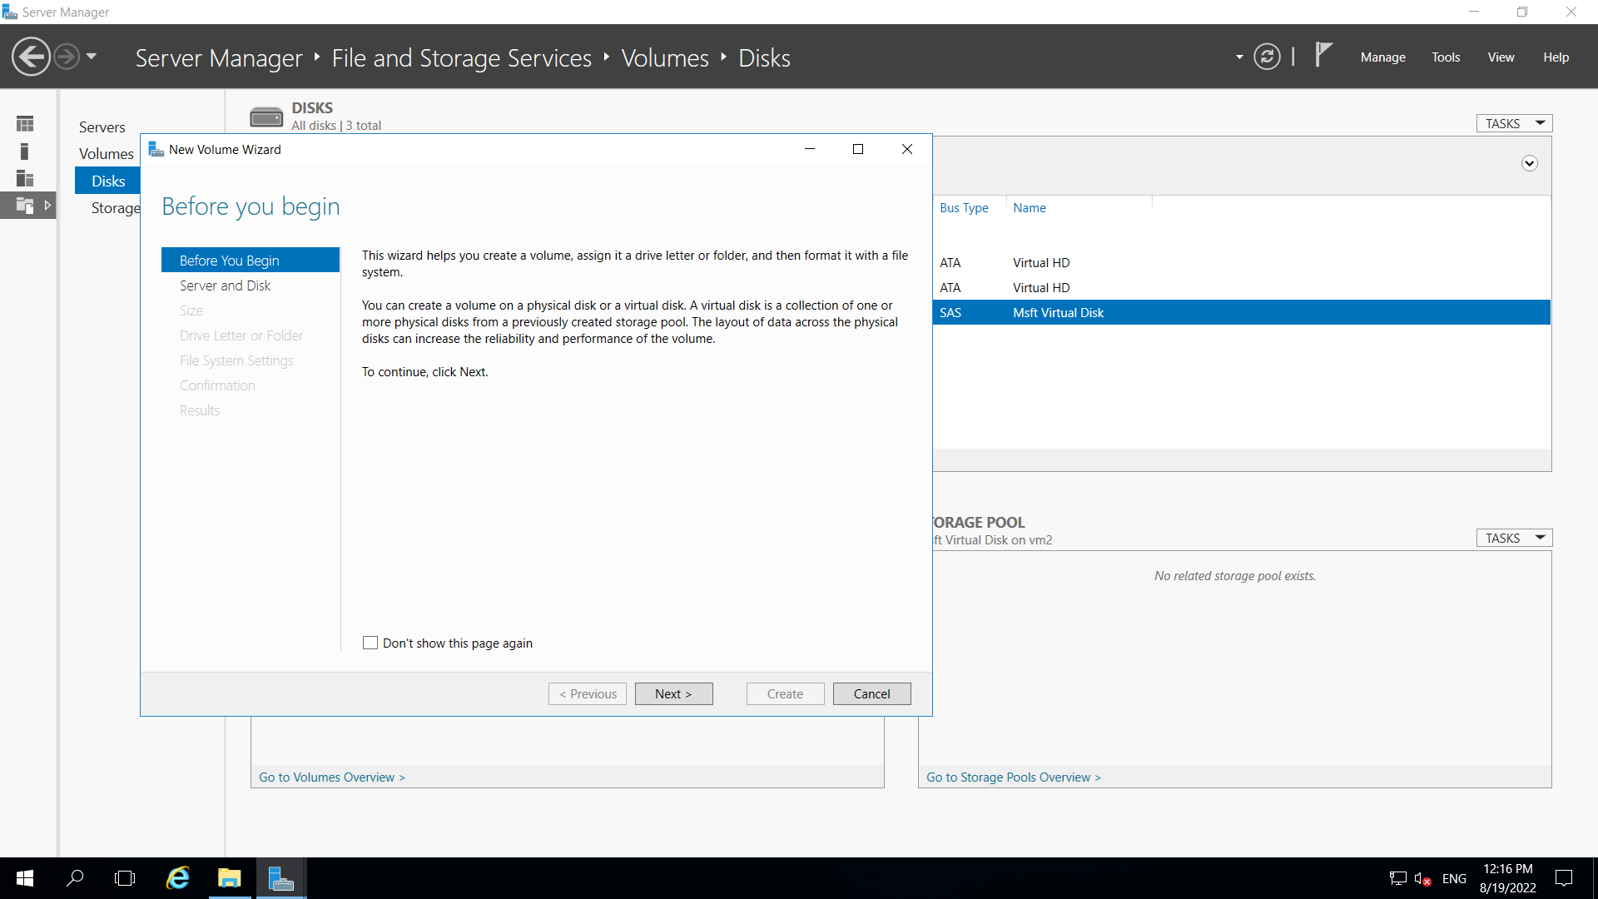

Step 7: After providing all details, click on create and your disk will get ready for use.

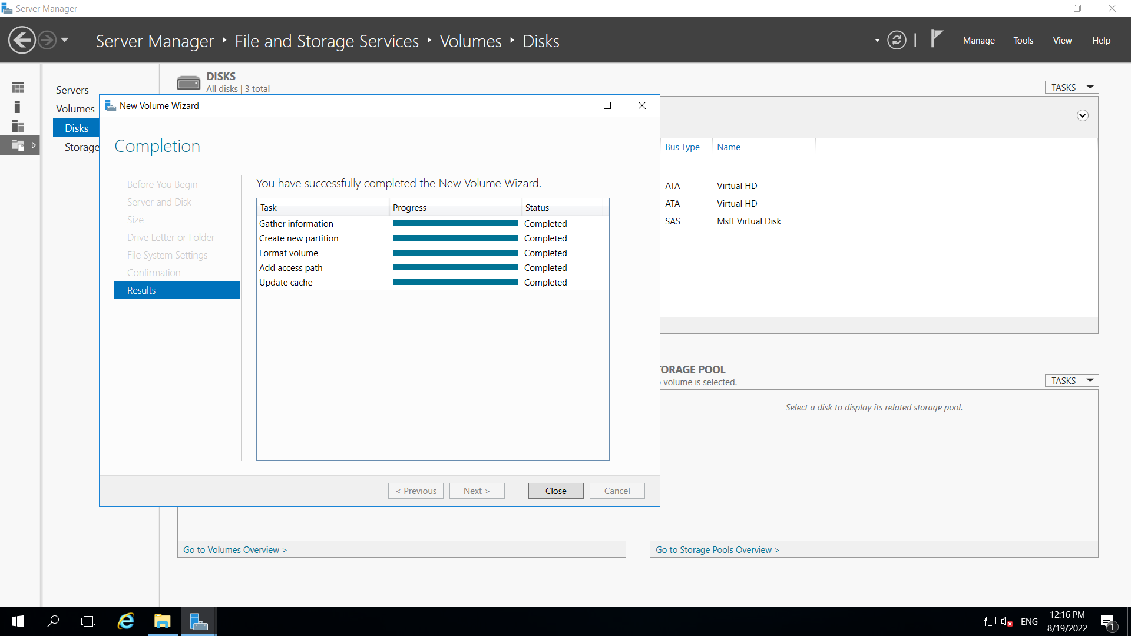

Step 8: Now, Go inside This Pc and you can find new added storage you have created present inside.

